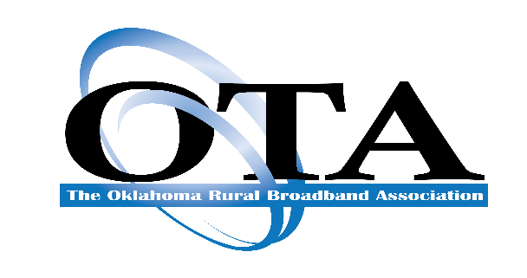

To: OTA Associate Members
From: Tom Karalis
Executive Vice President

It’s time again to register for our Annual OTA Accounting Conference, which will be held at the Downtown Sheraton Hotel in Oklahoma City on November 17th & 18th.

Our General Sessions will include several speakers from State and National organizations as well as representatives from our own Member Companies. Come learn about the latest Financial & Accounting issues and an update from Washington, DC

Conference highlights
- Two days of topics, with the opportunity for interactive Q&A with Presenters
- CPE credits for attendees
- Interaction with your peers throughout the Conference including a Welcome Reception on Thursday night.
A block of rooms at the Downtown Sheraton OKC has been contracted at the rate of $139 per night. The cut-off date to receive the group rate is November 3rd. Make your reservations by clicking on the Sheraton Hotel link:

https://www.marriott.com/event-reservations/reservation-link.mi?id=1664919528808&key=GRP&app=resvlink

This will take you to the hotel website where you will be able to confirm your room reservation. You may register online on our website or complete the attached registration form and e-mail it directly to me at tom@oklata.org.
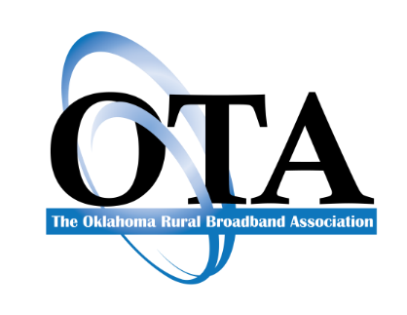
2022 OTA ACCOUNTING CONFERENCE
ITINERARY

Thursday, November 17th, 2022
12 Noon Luncheon
12:50 pm TK’s Welcome and Opening Remarks
1:00 pm Kirk Martin, Interim Executive Director, Oklahoma Broadband Office
1:30 pm Telco Results & Speed Testing Requirements – Donnie Miller, Pioneer
2:00 pm Leasing Accounting Standards – Tracey Welcher, Eide Bailly
2:30 pm Broadband Funding Opportunities – Lynette Hampton, Moss Adams
3:00 pm 30min Break
3:30 pm Cybersecurity – Robert Mayer, USTelcom
4:30 pm Working Remotely in 2022 - Rebecca Hartwig, Hartwig Staffing
5:00 pm Broadband Study Results – Scott Meyer, Innovative Systems
5:30 pm End of Day 1
6:00 pm Welcome Reception

Friday, November 18th, 2022
8:00 am Breakfast
8:50 am TK’s Welcome and Opening Remarks
9:00 am Washington DC Update – Eric Keber, WTA
9:30 am NECA Update – Teri Kessler
10:00 am Tax Update – Jason Oelrich, Eide Bailly
10:30 am 30 min Break
11:00 am Future of USF – Douglas Meredith, JSI
11:30 am OUSF / OCC Update – Ron Comingdeer, Comingdeer & Associates
12 Noon Thank You – End of Conference

You may register online or complete this registration form and email it directly to me at tom@oklata.org. If you have any questions or need further information, please do not hesitate to contact me at 405.525.7700 (Office) or 918.636.1313 (Cell).

I look forward to seeing everyone again!

Tom Karalis
EVP – The Oklahoma Rural Broadband Association

OKLAHOMA TELEPHONE ASSOCIATION
2022 OTA Accounting Conference Registration
12 Noon Thursday, November 17th - 12 Noon, Friday, November 18th, 2022

Downtown Sheraton OKC
1 N Broadway Ave, Oklahoma City, OK
(405) 235-2780

Company: ______________________________________________
Completed by: ______________________________________________
Phone: ______________________________________________

Associate Member Registration Fee: $175 per person
Non-Member Registration Fee: $225 per person

Name of Attendee/s: (Please include Email addresses for all registrants)

- ________________________________ Email: _____________________________
- _________________________________ Email: _____________________________
- _________________________________ Email: _____________________________
- _________________________________ Email: _____________________________
- _________________________________ Email: _____________________________
OTA ACCOUNTING CONFERENCE
SPONSORSHIP

Your sponsorship is greatly appreciated for the 2022 Accounting Conference. There are five levels of sponsorship which gives your company an opportunity to receive recognition throughout the Conference through signage and announcements

The levels of sponsorship are as follows:

Platinum Sponsors $ 1,000
Emerald Sponsor $750
Gold Sponsor $500
Silver Sponsor $250
Bronze Sponsor $150

Type of Sponsorship:

LEVEL AMOUNT
Platinum $
Emerald $
Gold $
Silver $
Bronze $
Please print or type:

Company Name: ____________________________________________

Contact Name: _____________________________________________

Telephone: __________________________________________

Address: __________________________________________________

City: ___________________________ St. ________ Zip ___________

Registration(s): $ ___________________
Sponsorship: $___________________
TOTAL: $ ___________________

Please return this form along with your credit card authorization or check made payable to:

Oklahoma Telephone Association
3800 N. Classen Blvd, Suite 215
Oklahoma City, OK 73118
Telephone: (405) 525-7700

THANK YOU FOR SUPPORTING THE
OKLAHOMA TELEPHONE ASSOCIATION

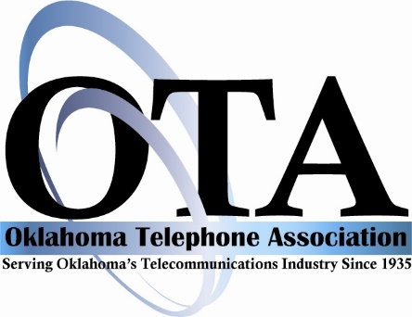

BILLING AUTHORIZATION FORM

I authorize you to charge my bill directly to the credit card listed below:

Company Name:_____________________________________________________

Charge to: _____ Visa _____ Discover _____ MasterCard _____AmEx

Card # ________________________________________________________

Exp. Date: _________

Print Cardholder’s Name: ______________________________________________

Billing Address: ______________________________________________________

City: __________________________________ State:____________ Zip_________

Phone: ____________________________

Amount to be billed:
Registration (s): $ _______________________
Sponsorship(s): $ _______________________

TOTAL: $ _______________________

